2023 William “B” Graham
Memorial Golf Tournament

Presented by the Graham Companies &
South Florida Council, Boy Scouts of America

Monday April 24, 2023
Miami Lakes Golf Club, Miami Lakes, Florida

The Graham Companies is pleased to announce that the 49th Annual 2023 William “B” Graham Memorial Golf Tournament will be held Monday April 24, 2023. Over the years, this event has proven to be extremely popular because of the fun and fellowship, great auction items, and good times had by all.

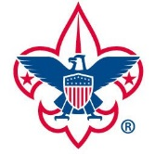
This year’s proceeds will continue to help fund the Boy Scouts’ mission of leadership & character development for more than 30,000 youth in Broward, Miami-Dade, and Monroe counties. Please see the attached Participant Commitment page.

Experienced and novice golfers alike are encouraged to attend. Bring your colleagues, clients, family, and friends out for a fun event of golf and fundraising for a truly worthy cause.

REGISTRATION:

Register online at:
https://sfcbsa.org/events/william-b-graham-memorial-golf-tournament-2/

For more information contact Diane Hickman at 305-709-3046 or
diane.hickman@scouting.org

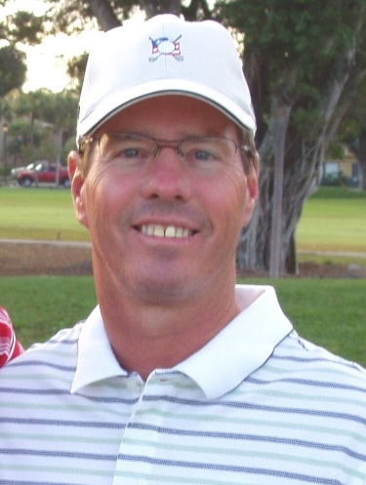

TOURNAMENT INFO

Miami Lakes Golf Club (Formally Shula’s)
7601 Miami Lakes Drive – Miami Lakes, FL
(826 and NW 154th Street)

Check-in begins at 7:00 am
Tournament starts at 8:00 am

Immediately following play:
Lunch, Awards & Silent Auction

OVERVIEW

- Four (4) Golfers per team
- Putting Green & Driving Range Open
- 7:00 a.m. Continental Breakfast
- Scramble Format
- Closest to the Pin Hole
- Beat the Broadcaster
- Hole in One Contest
- Longest Drive
- Straightest Drive Hole
- Silent Auction, Luncheon, and Drawing

AWARDS

Prizes for the top teams and individuals will be presented during the Awards Banquet at the conclusion of the tournament.

2023 William “B” Graham
Memorial Golf Tournament

Contact Name

Company

Address

City/State/Zip

Phone

Email

SPONSOR LEVELS

◻ $5,000 Gold Eagle ◻ $275 Individual
◻ $2,500 Silver Eagle ◻ $200 Hole/Tee
◻ $1,000 Bronze Eagle ◻ $100 Program Ad

◻ I cannot attend, but please accept this donation of $

PAYMENT OPTIONS

◻ Invoice Me ◻ Check enclosed

◻ Visa ◻ M/C ◻ AMEX

Card #:

Exp. Date:_________ Security Code:

Signature:

TEAM INFORMATION

Golfer Name Shirt Size

1A
2A
3A
4A

1B
2B
3B
4B
Gold Eagle Sponsor - $5,000:
- Player’s Gift Package includes: Participation in the tournament, meals, golf carts and participant gift. The amenities package has an estimated value of $325 per team. The portion of your contribution that is deductible as a charitable contribution for Federal Income Tax purposes is limited to the excess of the value of the contribution over the value of these goods and services.
- Four (4) Foursomes with Carts
- Full-Page Ad in Program Book
- Lunch, Shirt, or Reception Sponsor
- Hole and Tee Sponsorship
- Full-Page Ad in Program Book

Silver Eagle Sponsor - $2,500:
- Two (2) Foursomes with Carts
- Hole Sponsorship AND Tee Sponsorship
- Half-page Ad in Program Book

Bronze Eagle Sponsor - $1,000:
- One (1) Foursome with Carts
- Hole or Tee Sponsor
- Ad in Program Book

Individual Player - $275

Hole or Tee Sponsors - $200:
- Recognition sign on Hole or Tee
- Logo Recognition in Program Booklet

Program Book Advertisement - $100:
- Program Book Advertisement

Breakfast Sponsor - $1,500:
- One (1) Foursome with carts
- Recognition Sign at Breakfast
- Program Book Recognition

Lunch Sponsor - $3,000:
- Two (2) Foursomes with carts
- Recognition Sign at Lunch
- Program Book Recognition

Beverage Sponsor - $500:
- Recognition Sign
- Program Book Recognition

Please register online at:
https://sfcbsa.org/events/william-b-graham-memorial-golf-tournament-2/

For more information contact Diane Hickman at 305-709-3046 or
Diane.Hickman@scouting.org

