South Florida Council – Phoenix District

2023 Pinewood Derby
January 7th, 2023

At the Miami Springs Optimist Club
Co-Hosted by Troop 334 & Pack 425 (of Miami Springs)
Doors open @8:30am – 1st Race @9:00am

Welcome to Phoenix District’s
2023 Pinewood Derby

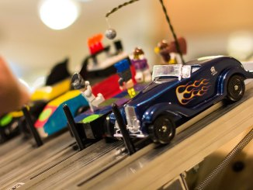
The Pinewood Derby, one of Cub Scouting’s most popular and successful family activities, is co-hosted this year by Troop 334 and Pack 425 and will be held at the Miami Springs Optimist Club on January 7th, 2023.

Pinewood Derby cars (small wooden models that Cub Scouts make with help from their families) are powered by gravity and run down a track. Every Cub Scout has the opportunity to design and build their own "grand prix" car to enter in the race. Win or lose, participating Cub Scouts should take pride in having done their best, as well as learning craft skills, rules of fair play, and good sportsmanship – all things they will remember for life.

Dates, Registration & Important Information

Date: Saturday, January 7th 2023. Doors open at 8:30am. 1st race starts at 9:00am, sharp.
Location: Miami Springs Optimist Club, 1101 Wren Avenue, Miami Springs FL 33166
Cost: $13 per racer – Early registration (available through Dec 20th)
$22 per racer – Regular registration (available between Dec 20th – Jan 4th)
Refunds not available. Substitute racer from same pack is allowed.
Registration: All participants (including any siblings/adults racing) must preregister online using link. There is no on-site registration.
Deadline: Registration link closes on Wednesday, Jan 4th at 11:55pm.
Cut Dates: November 26th and December 17th 10a-2p – Grace Lutheran Hall, 254 Curtis Pkwy, Miami Springs, 33166
Hosted by Pack 425 & 529
Car Turn In: Thursday, January 5th (@Miami Springs Optimist Club) between 6:30pm and 8:30pm.
Cars not turned in/inspected will not race.
Awards: Medals awarded to 1st, 2nd & 3rd place winners of each divisional race.
Trophies awarded to 1st, 2nd & 3rd place winners of the Overall District Champion race.
Additional awards for Craftsmanship and Originality.
Audience: Families & siblings are welcome to attend; but children must be supervised by an adult. Childcare is not provided.
Event Contacts: Event Chief – Vince Vigna (vincevigna@gmail.com)
Activity Chair - Tony Urbano (juanaurbano@yahoo.com)
District Director - Robert Graves (robert.graves@scouting.org)
Come hungry! Light breakfast, lunch and snack items for sale throughout the day.

What is needed

- Registered scouts must be in their Class A uniform.
- A great attitude!
- A new pinewood derby car to race. The car must follow the race car specifications listed below and must be turned in Thursday, January 5th 6:30pm – 8:30pm, at Miami Springs Optimist Club (1101 Wren Ave, Miami Springs).
- Current BSA Health and Medical forms (Sections A & B only) kept for the registered scouts by their pack.
- Optional items include chairs, toolbox, and/or camera.

Race Times
Doors open at 8:30am Jan. 7th

Division Call Time Race Time
Lions 08:45 am 09:00 am
Tigers 09:00 am 09:30 am
Wolves 10:00 am 10:30 am
Bears 11:00 am 11:30 pm
Webelos 12:00 pm 12:30 pm
AOL 01:00 pm 01:30 pm
Siblings/Adults/Open 02:00 pm 02:30 pm
Overall * 03:00 pm 03:30 pm

*The 1st place winners of each divisional race will compete against each other to determine the overall Phoenix District, 2023 Pinewood Derby Grand Champion.

General Information

- Races are held on separate tracks.
- Each car runs a minimum of 4 heats/races.
- Each car must pass inspection by the official inspection committee before it may compete. The inspection takes place at the weigh-in time.
  - Car owners will be informed of violations and given an opportunity to modify the car to meet these rules. If the car cannot be modified in time to race, it will not be allowed to race.
  - It is the participant’s responsibility to make sure the car is inspected/turned in, or the car cannot race.
  - Once the inspection is complete, each car will be sequestered to make sure the cars are not altered/changed after the inspection. Important: Make sure you tune your car before turning in.
- Unscoutlike or unsportsmanlike conduct by any participant (including audience members) will be grounds for expulsion from the competition and/or race area. This includes health safety measures (i.e., not keeping masks on during the event, or not adhering to social distancing requirements)

Race Car Specifications & Entry Rules

- Each car must pass inspection by the official inspection committee before it may compete.
- Each racing car must be new - never raced in previous derby races.
- Material and dimensions:
- Main body Structure must be made of wood
- Width: Not to exceed 2 ¾” inches
- Length: Not to exceed 7” inches
- Weight: Not to exceed 5.0 ounces
- Height: Not to exceed 4” inches
- The car’s official weight is determined by the official race scale, used during inspection. Inspection date is Wednesday, Thursday, January 5th at the Miami Springs Optimist Club (same location as race day), and will start at 6:30pm ending at 8:30pm. Cars not turned in/ inspected will not race.
- Design and details such as steering wheel, driver, spoiler, decals, painting, interior, and exterior detail are permissible as long as the car meets the length, width, height, clearance, and weight specifications.
- Cars with wet paint or wet glue will not be accepted.
- Only dry powder lubricant / graphite is permitted.
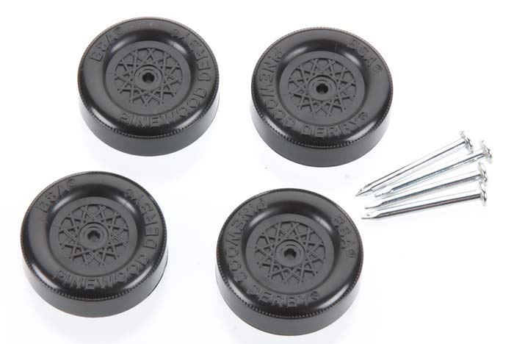
- Car Wheels & Axles
- The car must use official BSA Cub Scout wheels & axels (see example picture). They come inside your kit; but you can also buy them at the scout store or online, in different colors.
- Wheels may be polished; but you cannot lighten the wheels. (For example, no material can be removed from inside the wheel.)
- Electro-graphite coated axles are not allowed.
- Lathing, Angling, Canting, Reshaping, Round Crowning, Tapering, H-ing, V-ing, or dishing the tread surface are not allowed.
- Prohibited Items include
- Springs,
- Starting devices, propellants, or other propulsion,
- Liquids, wet paint, oil, sticky substance, or powders of any kind (other than axle lubrication),
- Wheel bearings, washers, and bushings,
- Hubcaps covering the nail head, and/or
- Loose/moving objects (Must be removed before the race)

Thank You!

From all of us at Phoenix District, and from your co-hosts at Troop 334 & Pack 425, we truly hope you enjoy the event and making the cars with your cub scout. Let us remember to make the event fun and fair, so all cub scouts get to experience healthy competition at this great event.

