South Florida Council
Boy Scouts of America
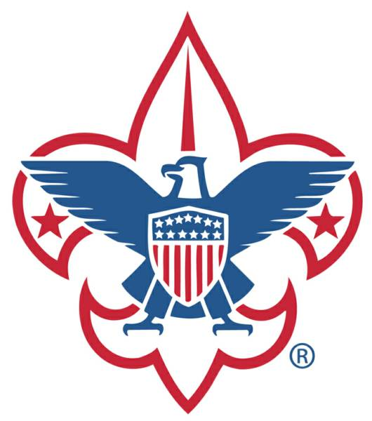
2021 MEMBERSHIP PLAN

Building Scouting’s Future Today!

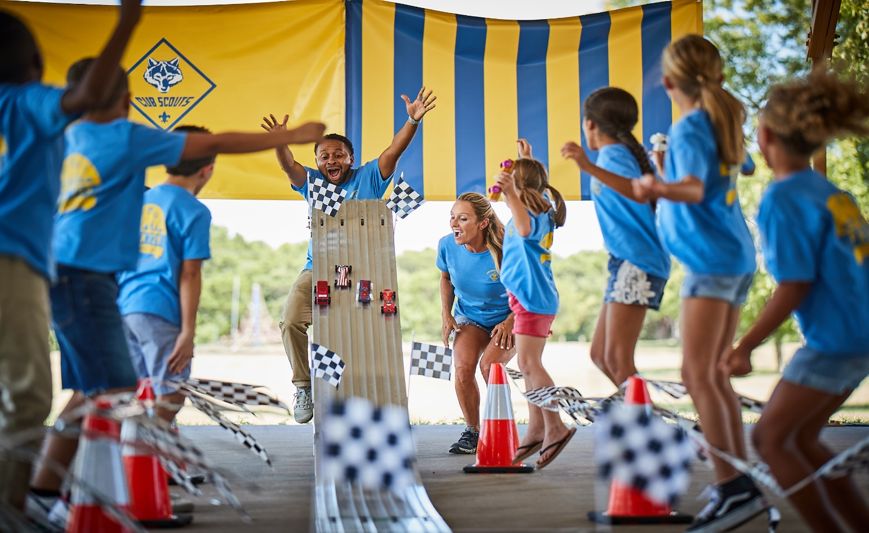

Serving the youth and families of Broward, Miami-Dade and Monroe Counties

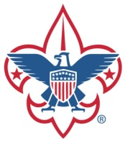
South Florida Council Boy Scouts of America

2021 MEMBERSHIP PLAN

Building Scouting’s Future Today!!

GOAL:

South Florida Council (SFC) has established a theme of BUILDING SCOUTING’S FUTURE TODAY in 2021! Our 2021 Membership plan addresses the areas of membership growth, membership impact and youth retention. Our complete plan is highlighted below.

MEMBERSHIP GROWTH:

South Florida experienced a significant membership loss in 2020 with the departure of a major partner and the pandemic. Our goal in 2021 is to start rebuilding a strong Scouting presence in South Florida by achieving a membership growth of 2.1%, or 974 youth. To accomplish this objective, we have implemented some new strategies that will help achieve this goal:

Manpower – Each District and Unit is to recruit for their committees; a Membership Chair, New Member Coordinator, and Spring and Fall Join Night (JSN) coordinators.

My.Scouting.org – Every unit is to update their unit information in this site and the unit new member coordinator is to keep this site relevant. It should be informative, welcoming, and inviting, so families will want to join your unit. Here is a link to a resource guide: https://www.scouting.org/resources/online-registration/

BeAScout.org – A year-round recruitment tool to be used by every unit. Our first and easiest step to increase access for new members to find information about Scouting near them. (google search “Scouting Near Me”) The New Member Coordinator will be responsible for following up on all lead inquiries within 1-2 days.

Starting New Packs – The professional staff will identify and start 2 new units in underserved areas of each district and will serve as the Cubmaster for the first few months while training volunteer leadership With the assistance of the district volunteer team each district (5 districts) will identify and prioritize 20 chartered organizations that will partner with SFC in establishing new units.
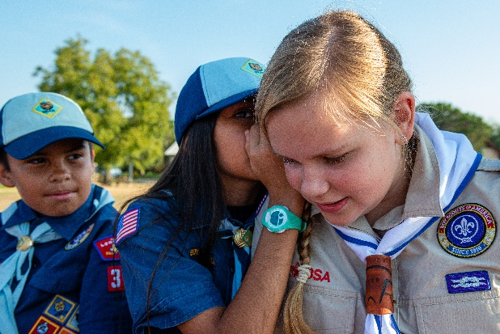
April Spring Round Up – SFC has implemented a new strategy, with the goal of recruiting a minimum of 125 new Cub Scouts this spring. SFC, working with the unit commissioners and membership committees in each district, will conduct a coordinated, one week, Spring Round Up. The theme for this initiative is “Hunting for Lion and Tiger Scientist”. Every Pack will be contacted to participate and trained to ensure a successful campaign. The focus is on all the religious organizations and private schools in each district and Packs will recruit from these public schools, as well as the private schools and religious organizations in their surrounding areas. Welcome new members and families.

Day Camp; Theme is Weird Scientists!!! - Bring a friend to day camp. Every newly registered never-before-registered Cub Scout will receive a day camp discount to either the SFC virtual or in-person day camp.

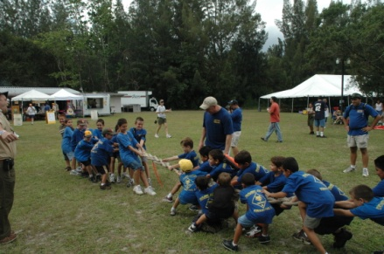
Join Scout Night Week Fall Recruitment – SFC’s major recruitment drive conducted every fall in September is entitled Join Scout Night Week. Back up alternative week if needed will be 2 weeks later. SFC will be going back to a coordinated, one-week recruitment campaign in September in all the public and private schools in South Florida to help us achieve our objectives. Over the last 3 years (2018-2020) we have averaged 1500 new Scouts during this campaign, which was run throughout the entire month of September. Our goal is to recruit a minimum of 1,000 new Scouts this year by conducting a focused, coordinated one week sign up council wide – providing a better opportunity for us to market the campaign through news and media outlets and focusing our volunteers in on this major one night initiative. Follow up is to be conducted with the organizations identified as potential charter organizations – by the fall, these organizations will have had time to identify leaders, get them trained and be ready for youth recruitment.

Welcoming - Once new families join Scouting the New Member Coordinator welcomes and guides them through understanding the uniforms, how advancement works, costs, and the culture within the unit. Include this link to Scouting’s Commitment to abuse and the safety of our youth in your welcome message. https://www.scouting.org/about/youth-safety/

Membership Projections – Below are the traditional membership year-end projections for South Florida Council through the year 2023:

2020 Actual | 2021 Year End Projection | 2022 Year End Projection | 2023 Year End Projection
2,733 Youth | +974 = +2.1% | +1274 = +4.3% | = +5%
MEMBERSHIP IMPACT:

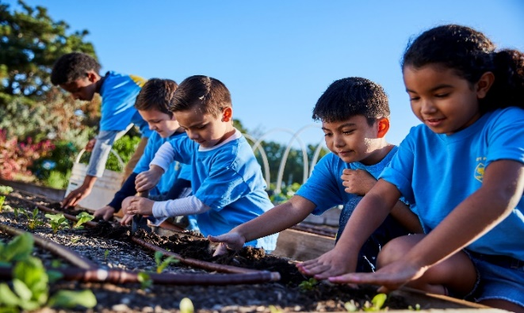
South Florida Council has experienced an increase in Total Available Youth (TAY) over the past few years. Achieving an increase in market share will be a side effect of increasing our membership numbers. Our staff and volunteers are working hard to identify underserved areas in each district and establishing partnerships to start new units in theses identified communities. Below is a breakdown of out TAY and Density figures for the past few years:

2018 TAY = 516,666 6,666 traditional youth served 0.29% Total Traditional Density
2019 TAY = 517,590 6,561 traditional youth served 1.26% Total Traditional Density
2020 TAY = 639,196 2,733 traditional youth served 0.43% Total Traditional Density

Program | 2019 Density | 2020 Density | 2021 Goal | 2022 Goal | 2023 Goal
Cub Scouts | 0.99% | 0.34% | 0.81% | 1.79% | 2.36%
Scouts BSA | 2.02% | 0.98% | 1.23% | 2.51% | 2.57%
Venturing | 0.12% | 0.05% | 0.06% | 0.07% | 0.07%

YOUTH RETENTION:

Upon completion of our re-chartering cycle at the end of November, dropped youth reports will be produced for each district. The District Executive, in conjunction with their Membership Committees, will be conducting campaigns to recapture as many dropped youth as possible. This campaign will consist of the following:

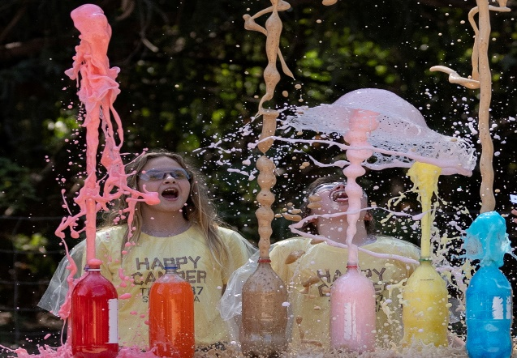
- Comparing dropped youth reports to registration reports from spring activities of each district to recapture those Scouts that may have not been included in the re-charter process but are still active.

- Names of the Webelo II’s (AOL Scouts) from the dropped youth report will be shared with Troop leaders in each district to make sure all the youth who crossed over to Scouts were not lost in the process.

- Cub Recovery campaign – a direct mail and follow up phone call campaign will be conducted by membership committees and unit commissioners to invite all dropped youth to re-register with a viable unit, with a strong program.

- Welcoming calls and/or letters are to be mailed to all new Scout families by the New Member Coordinator welcoming them to the program and providing information on where to find valuable resources to help their unit be successful – websites, newsletter, What’s app, community pages, etc. Please include the BSA statement on youth protection. Include this link to Scouting’s Commitment to abuse and the safety of our youth in your welcome message. https://www.scouting.org/about/youth-safety/
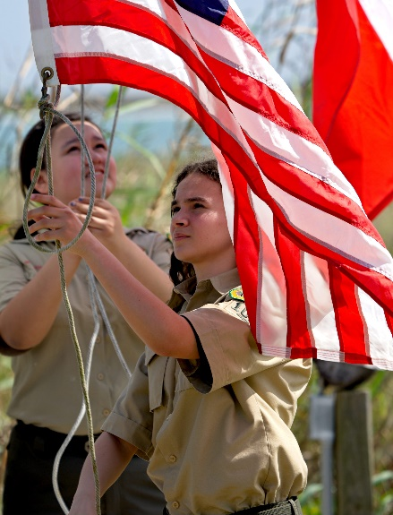
- Conduct Fall Cub Scout Fun days in October designed to get youth and parents engaged early to help increase retention. There will be a Fun Day in Broward, Miami-Dade, and Monroe Counties.

- Unit commissioners will monitor the health of new units and work with the leadership to ensure there is a healthy program for youth and a leader succession plan in place to avoid a unit dropping due to a key leader stepping down or moving from the area.

Follows is a month by month breakdown of our 2021 Membership Plan.

2021 Membership Plan
Month-by-Month

January
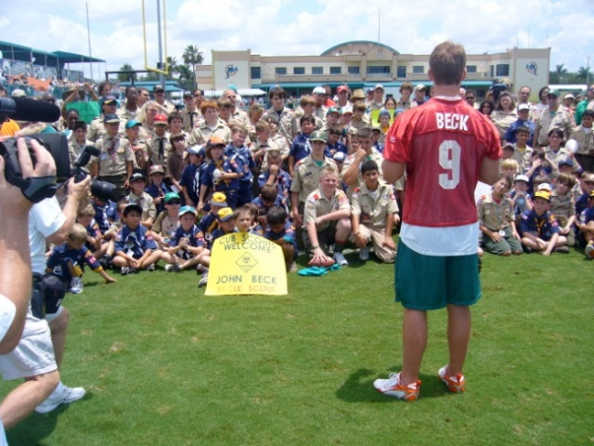
- Units and Districts Recruit Spring Round Up Chairs and New Member Coordinators (Manpower)
- Continue Dropped Youth Campaign – calls to invite back
- Visit Prospective Chartered Organizations
- Institutional Head (IH) visits
- Packs – arrange appointments for Webelos II (AOL Scouts) to visit potential Troops

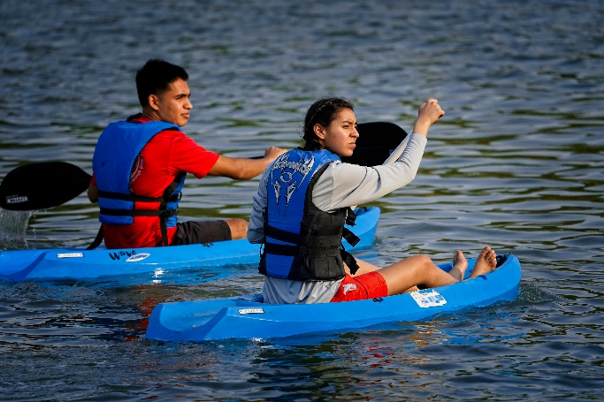
February

- Visit Prospective Chartered Organizations
- Train district membership committees in how to conduct, and recruit during a JSN event
- Unit Growth Event for New Units – rallies, open houses, weekend events at parks, etc.
- Day Camp Promotion
- Plan Webelos-to-Scouts Crossovers
  - Pack leaders schedule Troop visits
- Continue IH visits

March

- Visit Prospective Chartered Organizations
- Seek collaborative partnerships with the potential charter orgs – Churches, Schools, Boys and Girls Clubs, YMCA’s, Civic Organizations, etc.
- Advertise Joining Events on parent groups, Facebook, What’s App, community pages, etc.
- Unit Growth Event for New Units – rallies, open houses, weekend events at parks, etc.
- Train unit leaders in how to conduct, and recruit during a JSN event

April
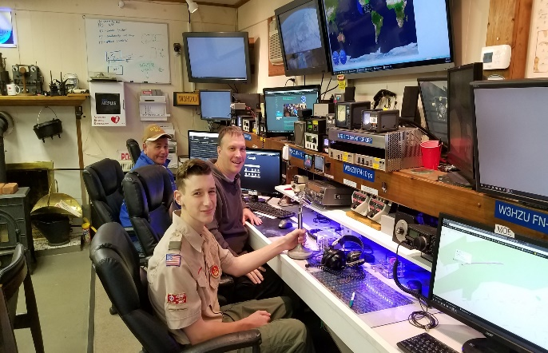
- Visit Prospective Chartered Organizations
- Unit Growth Event for New Units – rallies, open houses, weekend events at parks, etc.
- Spring Round Up Recruitment Campaign
- Advertise Joining Events on parent groups, Facebook, What’s App, community pages, etc.
- Distribute Flyers for Cub Scout Day Camp
- Cub Scout Day Camp Recruiting
  - Bring a Friend to Day Camp to join

May

- Spring Fun Day – Camp Elmore
- New Leader training
- Visit Prospective Chartered Organization
- Public Service Announcements/Morning School Announcements
- Advertise Joining Events on parent groups, Facebook, What’s App, community pages, etc.
- Welcoming calls to new families by unit New Member Coordinators

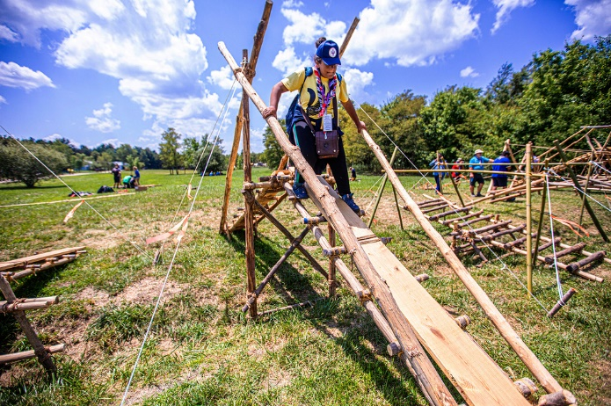
June

- Visit Prospective Chartered Organizations
- Cub Scout Day Camps
- Scout Summer Camps
- Unit Planning Conferences/ JSN Planning
- Recruit Fall JSN Coordinator
- Membership Inventories
  - Minimize drops by asking families if they will continue in the fall
  - Conduct unit inventories using www.my.scouting.org resources

July

- Visit Prospective Chartered Organizations
- JSN Planning
- Visit Principals Before Schools Open
- JSN Committee Meeting
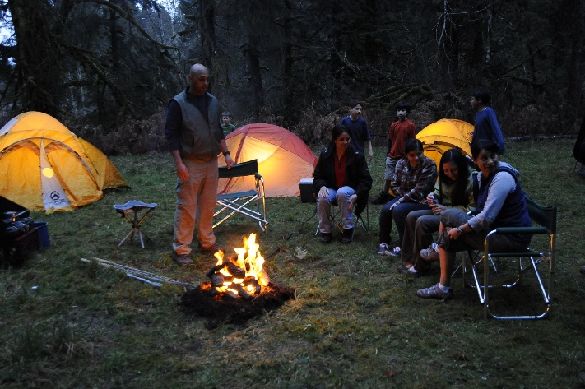
- Membership Inventories
  - using www.my.scouting.org resources
- Re-charter packet email distribution by Commissioners
- Commissioners schedule re-charter turn-in dates and locations
- Invite a principle to a Scouting event

August

- Re-charter window opens
  - (YPT MUST be current for All adults through 10/01/2022 to re-charter)
- Visit Prospective Chartered Organizations
- District Roundtables - Conduct JSN Trainings
- Schedule JSN’s
- Commissioners schedule application turn-in sites and dates
- Month of September District Roundtables - Conduct JSN Trainings (Backup)

September

- Visit Prospective Chartered Organizations
- Coordinated Fall Join Scout Night campaign September - Rallies and JSN’s
- Open Houses at Schools
- Turn in applications
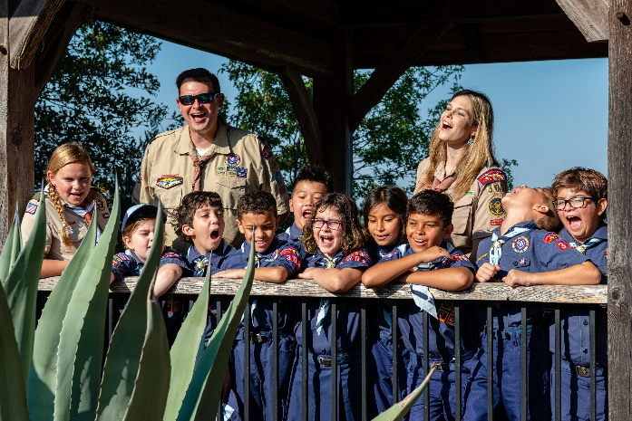
- Hold Special Events for Recruiting
- Issue Invitations/Promote Fall events
- Re-charters due to Commissioners

October

- Visit Prospective Chartered Organizations
- JSN and Rallies follow-up
- Unit Growth Event for New Units – rallies, open houses, weekend events at parks, etc.
- New Leader Training
- Chartered Organization Representative Orientation
- Troop & Crew Open Houses
- Fall recruitments - Promotional/Recruiting Events
- Cub Fun Days (North & South Areas)
- Flyers/Recruiting fall events

November

- Visit Prospective Chartered Organizations
- Unit Growth Event for New Units – rallies, open houses, weekend events at parks, etc.
- More Rallies & JSN’s
- Pack, Troop & Crew Open Houses

December

- Visit Prospective Chartered Organizations
- Dropped Youth Campaign – calls by New Member Coordinators to invite back

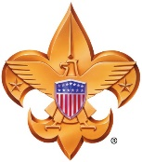
Building Scouting’s Future Today!!!!

SOUTH FLORIDA COUNCIL
BOY SCOUTS OF AMERICA
www.sfcbsa.org

