Planning Guide for VIRTUAL Cub Scout Recruiting
in the pandemic era…
ROCKET
INTO
SCOUTING

South Florida Council, 15255 NW 82nd Avenue, Miami Lakes, FL
305-364-0020 | www.SFCBSA.ORG
Overview

Join Scouting Night is a recruiting event held at every elementary school to give the youth served by that school an opportunity to join Cub Scouts. It is a cooperative effort between our district membership teams and our pack leadership. Join Scouting Night should be a fun informative night for prospective families. The goal for the evening is to register youth in Cub Scouts.
This year, Join Scout Nights may look a little different and we must be open to trying something new. This includes implementing a Virtual Join Scout Night alone or in conjunction with a traditional open house to offer new families to join. Please keep in mind that a Join Scouting Night should not take place on the same night as “Back to School Night” or the monthly pack meeting.
For many parents, this is the first experience they have with Scouting, so their initial impression is crucial. If parents leave with a bad experience, they may never give scouts another chance. For this reason, we all need to work hard to ensure that the new families feel welcomed and informed. Remember, parents trust us with their most precious treasures- their children. We must always do our best to meet their highest expectations.
A national survey of parents who attended a Join Scouting Night was conducted and sheds light on some reasons why parents who come may choose not to enroll their child in Scouting or claim to be dissatisfied. In the majority of instances where parents were unhappy with their Scouting experience, they felt that the Join Scouting Night lacked organization, offered a poor program, the organizers were not prepared, or there was no follow up to ensure the child was placed in a functioning den.
This Virtual Join Scouting Night plan is designed for “Plug and Play” purpose and to limit these common pitfalls by providing easy to follow steps in preparation for, conducting, and follow up for our Virtual Join Scouting Nights. This will make it easier for pack, district, and council membership teams to accomplish their mission of ensuring that every youth has an opportunity to enjoy the benefits of Scouting.

Thank you for all you do for the youth of our community!
Don’t forget……
- Make sure your BeAScout unit pin is updated
- Go to www.sfcbsa.org/virtual-recruiting for recruiting materials and best practices
- Make sure your new leaders get the training they need
Organizing a Virtual Join Scout Night

Picking the Virtual JSN Date:
- Not on a pack meeting night, please choose a “stand-alone” recruitment night.
- Not on Back to School Night (some packs find it helpful to have it a few days after Back to School Night so they can hand out flyers).
- Know and consider the timing of the School’s E-newsletter. This is a virtual announcement that gets sent to all the parents in the school. Many classes use “Class Dojo”, “WhatsApp”, and other group chat apps too.

Marketing Items:
- Use the attached E-Newsletter announcement or create your own to share with your School E-Newsletter. The first one we share is like a flyer and the second is shorter for ease of implementing in a school newsletter or with the PTO.
- Create an event on Facebook or have the Council/District do one for you to share/spread the news through geo-fencing.
- Use neighborhood email lists and platforms such as NextDoor to market your Virtual JSN.
- Make use of Join Scout Night signs, available NOW at the Council, to put in neighborhood entry ways and public places with permission.
- Post signs with QR Codes that can be posted in public places where families can be walking. Free QR codes can be found here: https://www.the-qrcode-generator.com/

Schedule a Virtual Meeting:
Virtual Pack meetings can be done through platforms such as Zoom, Facebook Rooms and Google Meet. Both are free and have some limitations. Be sure you or the volunteer preparing for the meeting is familiar with virtual meetings before conducting your own.

Virtual Meeting Presentation:
The Virtual Meeting is like a “Plug and Play”.
- Download “Pack JSN PPT” from www.sfcbsa.org/virtual-recruiting/. This is a PowerPoint Presentation with everything families are looking for when considering joining.
- Once you have downloaded the PowerPoint go through it and PLUG in the details for your Pack such as: Leaders names, planned pack programs (examples are given in the presentation, but you need to replace them), Pack/Den photos. The PowerPoint is very general, and you have the authority and power to edit and change to meet the needs of your unit. It is a template to
- The Presentation is YOUR JOIN SCOUT NIGHT. Running the presentation should only take 30 minutes or LESS.
- Zoom Tips:
- When sharing your screen be sure to check two important boxes to enable audio and marking your presentation as a video. This will allow participants to hear and see the embedded videos smoothly.
- When scheduling the Zoom be sure to enable the “Waiting Room” feature so that you can start the presentation when the presenter is ready.

When parents come to a Join Scout Night, they are looking for a quality program. The pack leadership should develop their calendar, identify any gaps in leadership, and plan an outdoor activity, whether virtually or as a group depending on self-distancing restrictions, for the pack within the first month after Join Scouting Night.

Hold your Virtual Join Scout Night
Start the meeting 10-15 minutes early to allow families to connect online. Some people are not well trained in Virtual Meetings so be prepared to mute participants if there is a lot of background noise. Also give yourself an addition 2-5 minutes after the initial start time to allow families to still join in.

PLAY and Review the presentation with your families. Make sure to ask if families have any questions.
At the end of the presentation let parents know that you are emailing the youth and adult applications to them. These are available for download at www.sfcbsa.org/virtual-recruiting/. They are fillable PDF applications and can be processed at the Scout Service Center with an email approval from the unit leader with the following statement; I (Cubmasters Name) give permission to register (Youth’s Name) in Pack (XYZ).

Hey South Florida Scouting units – want to help us show that the Scouting adventure and spirit is continuing no matter what gets in our way? We know many of you are developing some pretty inventive ways to keep Scouting going in your unit, family and community. Why not use this opportunity to get other friends in on the fun?
Yes – you can recruit new youth into Scouting and have them join you in your Virtual Scouting Events and Meetings – and the best part is you can earn a pretty cool, one-of-a-kind, recruiting patch in the process! I mean, how many times do you get an opportunity to do cool Scouting adventures while in the middle of a world-wide pandemic? That’s certainly “Scouting in Action!”
You may find that many of your neighborhood friends are looking for new things to do because their extracurricular programs that they are usually busy with might not have a lot going on right now. Why not ask them to join you on your Scouting adventure?
Any Scout that recruits a friend to join Scouting will get a special, extra-awesome, “Virtual Recruiter” Patch.
What’s not to lose? Besides, don’t you think the world needs more Scouts – especially during times like these? So…Stay Calm and Scout On and let’s get more Scouts recruited!
Questions? Contact your district executive or Peggy Durbin at peggy.durbin@scouting.org

THE PROCEEDING PAGES ARE
EXAMPLES OF FLYERS FOR YOU TO INSERT YOUR PACK INFORMATION AND SHARE.

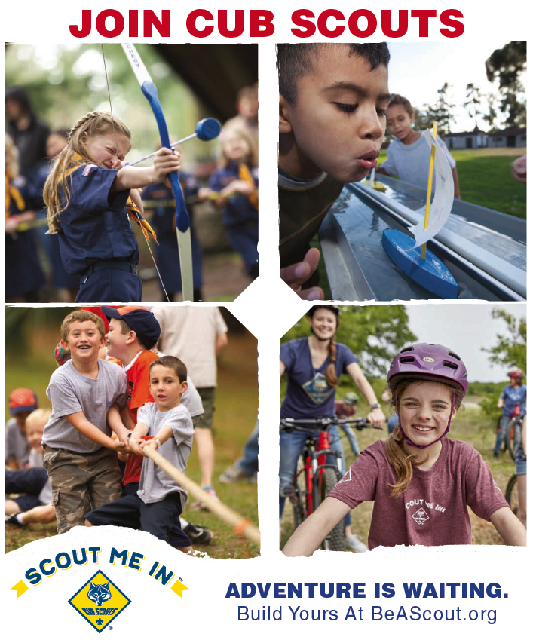

Cub Scout Recruitment Flyer (Draft)
Electronic Version for PTO eNewsletter

Invitation to Join Cub Scouts

Who? Parents/Guardians of Kindergarten – 5th grade youth (Boys & Girls)
What? Invitation to join Cub Scout Pack Insert your number
When? Insert Date
Where? Online Zoom Invitation
How? Send us your name, preferred email address, phone number, name of the youth and grade at Insert your email address. We will send you a Zoom link invitation.
Why? A life enhancing experience in character development and leadership while having lots of fun.

MORE INFORMATION:
Join Scouting Video: https://www.youtube.com/watch?v=qnDdD8UYVTg

More Questions? Send us an email with your name and phone number.
Contact us at: Insert Pack email.
Thank you!
Your Name

