Spring Direct Contact Leader Training
BALOO (Basic Adult Leader Outdoor Orientation)
April 24^{tth} and 25th, 2021 Saturday 8:00 am to Sunday 2:00pm
Sign in at 7 am till 8 am!! Please arrive on time!

Address: Saint Faiths Episcopal Church
10600 Caribbean Blvd, Cutler Bay, FL 33189

Cost: $25 (Includes 2 lunches, 1 dinner, 1 breakfast)
Please let Enrique Rogers know if you have any food allergies.

Register Online: https://sfcbsa.org/events/phoenix-baloo-training/

All Districts Welcome!

Phoenix District Training Chair
Contact info: Enrique Rogers, Email: enrique.rogers@comcast.net
Phone: (954) 325-1615

Phoenix Training Staff Advisor
Cliff Freiwald Phone: (305) 709-2976, Email: Cliff.Freiwald@scouting.org

Due to COVID-19 restrictions face coverings will be required.
Please be sure to wear your mask!
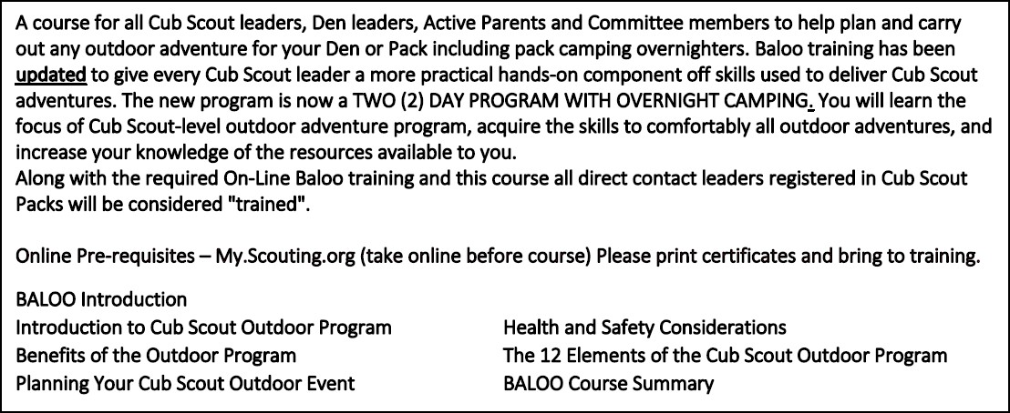

What to bring: Face covering, Tent, Sleeping Bag, sturdy shoes, change of clothes, sleeping attire, mess kit, drink canister, soap, washcloth, towel, sunglasses, camp chair, camera, notebook, pen or pencil, coat or jacket, cap, gloves, cot or sleeping pad or mattress. Cub Scout six essentials and lots of Cub Scout cheer!

