South Florida Council Boy Scouts of America

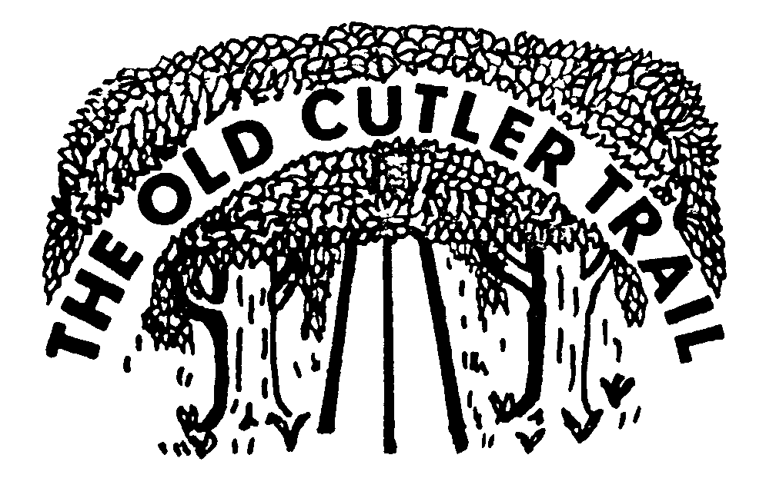

*2021 Old Cutler Trail Hike*

Saturday, December 11, 2021

What is it? The Old Cutler Trail Historical Hike is a 13.7 mile walk that takes Scouts and their families along beautiful the South Florida scenery from downtown Miami, Coconut Grove and down Old Cutler Road. This will be the 46th hike, and we would like all Scouting families to come out and take part in this year’s tradition.

When? Saturday, December 11, 2020. Check-inopens at 7:30 a.m. and closes at 9:30 a.m. All units must register at the check-in station. Every unit must complete a roster of youth and adult participants prior to starting the hike. Names of each person registered online meets this requirement.

Where? The hike will begin at the Torch of Friendship (in front of Bayside Mall) at 401 Biscayne Blvd. in downtown Miami. The hike will end at St. Thomas Episcopal Parish located at 5692 SW 88 Street (North Kendall Drive), Coral Gables, FL 33156. The parking lot will open at 6 a.m.

Supervision? A parent or guardian must accompany and be responsible for each Cub Scout and other family members for the entire event.

Cost? $7.00 per hiker. Units that pre-register will have first priority of patches; additional patches will be ordered if necessary. Online registration ends Wednesday, December 8th at **Noon**. You may register on the day of the hike. (Please note that on-site registration is $10.00 per hiker, so please pre-register!)

Medals ($10) can be purchased during registration or at the hike.

Refund: Refunds are not available but fees are transferable to another Scout on this hike.

Food? Food Not Provided with Registration.

What to Bring? **Water is a must! Bring a cup or water bottle!** Units are encouraged to have a support vehicle for the hike. Please have support vehicle drivers check-in for route maps. Maps will be available on [sfcbsa.org/event-list/](https://sfcbsa.org/event-list/) and provided at check-in.

Weather? This is a “rain or shine” event.

Registration: Will be available online at [sfcbsa.org/event-list/](https://sfcbsa.org/event-list/) . Multiple registrations for a unit will be combined into one entry per unit in the check-in spreadsheet. Only one person from a unit should check-in.

No Refunds for Scouts cancellations, no refunds for Scouts that are No Shows. Fees may be transferred to another Scout for this same date, and event if Cliff Freiwald is notified 24 hours prior to start of activity via e-mail.

Insurance: Liability as well as Sickness and Accident Insurance is provided for all registered members and leaders of the South Florida Council.

More Info? Fred Kimball, 786-385-3832, [fkimball@smcc.us](mailto:fkimball@smcc.us) [Cliff.Freiwald@scouting.org](mailto:Cliff.Freiwald@scouting.org) 305-709-2976

2021 Old Cutler Trail Hike Registration #712Return to South Florida Council

December 11, 2021 Fax: 305-821-6222 15255 NW 82nd Ave, Miami Lakes FL 33016

|  |  |  |  |  |
| --- | --- | --- | --- | --- |
| Unit Number | Pack: | Troop: | Crew: | Other Youth Group: |
| District: | | Contact Name: | | |
| Phone: | | Email: | | |
| Total Participants: | | @ $7 = | # medals: | @ $10 = |

Total amount enclosed $ Make checks payable to South Florida Council.

If paying by credit card, call 305-364-0020 to provide card information.

List all participants

|  |  |  |
| --- | --- | --- |
| Adults | Scouts | Scouts |
|  |  |  |
|  |  |  |
|  |  |  |
|  |  |  |
|  |  |  |
|  |  |  |
|  |  |  |
|  |  |  |
|  |  |  |
|  |  |  |
|  |  |  |
|  |  |  |
|  |  |  |
|  |  |  |
|  |  |  |
|  |  |  |
|  |  |  |
|  |  |  |
|  |  |  |
|  |  |  |
|  |  |  |
|  |  |  |
|  |  |  |
|  |  |  |
|  |  |  |