Spring Direct Contact Leader Training BALOO (Basic Adult Leader Outdoor Orientation)
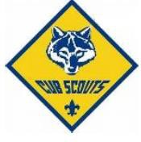
March 13-14, 2021 Saturday 8:00 am to Sunday 2:00pm
Sign in at 7 am till 8 am!! Please arrive on time!

Address: Camp Elmore, 3301 SW 142nd Ave, Davie, FL 33330

Cost: $25 (Includes 2 lunches, 1 dinner, 1 breakfast)
Please communicate with Yamilet Torres if you have any food allergies.

Register Online by March 5, 2021 at
https://sfcbsa.org/events/sawgrass-baloo-training/

All Districts Welcome!
Contact info: Jeanine Kinsey, Email: songbirdscout@gmail.com, Phone: (954) 778-0599 Training Staff Advisor
Denis Silva 305-364-0020, ext 233 Denis.Silva@scouting.org

Due to COVID-19 restrictions face coverings will be required.
Please be sure to wear your mask!
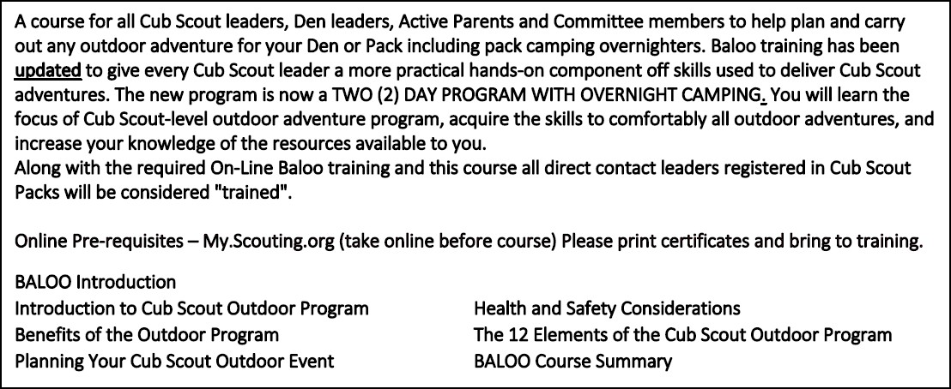

What to bring: Face covering, Field Uniform, Tent, Sleeping Bag, sturdy shoes, change of clothes, sleeping attire, mess kit, drink canister, soap, washcloth, towel, sunglasses, camp chair, camera, notebook, pen or pencil, coat or jacket, cap, gloves, cot or sleeping pad or mattress. Cub Scout six essentials and lots of Cub Scout cheer!

