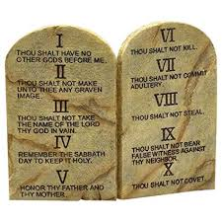 Ten Commandment Hike
__________________________________________________________________________________________
What is it? The 10 Commandment Hike is a 5 mile walk that will stop at 5 different Houses of Worship. At each stop a talk will be given on two of the 10 Commandments. This is a 4-hour HIKE!
Purpose? To Examine GOD’s Laws.
When? Saturday, January 18, 2020. Check-in opens at 8:30 a.m. All must register at the check-in station. We will start at 9am and finish around 1:00pm due to the time involved at each stop.
Where? First Methodist Church, 8650 W. Sample Road, Coral Springs, FL 33065.
Cost? $5.00 per hiker (siblings invited). Siblings under 5 years old are FREE.
Preparation? Wear appropriate shoes and clothes (Class A), carry water bottle to stay hydrated, wear sun block and/or hat. Practice Leave no Trace and the Buddy System.
What to Bring? Water is a must! Please note: we will have support vehicles along the way. Water refill stations will be provided at each stop. Pack a lunch so that we can eat together at the end of the hike.
Weather? This is a “rain or shine” event.
Supervision? A parent or guardian must accompany and be responsible for each Cub Scout and other family members for the entire event.
More Info? Hike Masters: Charles and Melissa Ruelke melissibird@yahoo.com
or 561-715-9059

Start: 1. First Methodist Church
2. Veteran’s Park
3. St. Mary Magdalene Episcopal Church
4. Abundant Life Church
5. Forest Hills Park
Finish: 6. First Methodist Church

