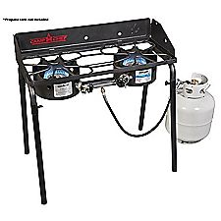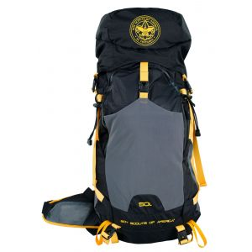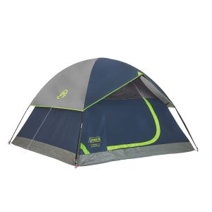

Miami Scout Shop is having
GET READY FOR CAMP EVENT
May 12, 2018, 10am – 2 pm

Short classes on:
Knot tying
Pioneering Gadgets
Dutch Oven Cooking
How to fit and pack a backpack
How to set up a tent
Camping First Aid
Come in and join the fun

