Hurricane District
Intro to Outdoor Leader Skills (IOLS)
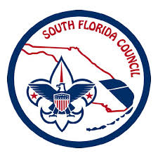
Training

September 23, 2017

What is it? The course is intended to provide troop leadership with the information and tools they need to lead successful Boy Scout troops. Introduction to Outdoor Leader Skills, and Youth Protection training must be taken to be considered “trained” as a boy scout leader.

Cost? No cost to participants for Leader specific training.

Save the Date Introduction to Outdoor Leader Skills (S11), Friday, October 13th to Sunday, October 15th, 2017. Check-in begins at 4:00 p.m. on Friday. The course will run through until Scout’s Own on Sunday. This is a mandator campout to complete for the IOLS Training, held at camp Elmore.

Who? This course is recommended for Scoutmaster, Assistant Scoutmaster, Committee Members and Webelos II Leaders.

When? Saturday, September 23, 2017, 9:00 am– 3:00 pm.

Where? Sunset Church of Christ, 12001 SW 72nd Street, Miami, FL 33183.

Registration? Pre-registration is required. Complete registration online at SFCBSA.ORG Calendar before Friday, September 15, 2017.
Outdoor Portion Pre-register before October 6th at SFCBSA.ORG Calendar.

Insurance? Liability, as well as Sickness and Accident Insurance, are provided for all registered members and leaders of the South Florida Council.

Bring? Pen, Notepad, Drinking cup and lunch for the indoor portion.

More Info? Cody Loucks 636-208-6365

